**PROJECT REPORT**

Zinema – Management Software

Distributed System

**Students**

Andrei Cioanca – 266105

Claudiu Rediu – 266129

Dominika Kubicz – 266148

Nikita Roskovs – 266900

Stefan Harabagiu – 266116

**Supervisors**

Jakob Knop Rasmussen

Jan Otto Munch Pedersen

**Abstract**

The following report will present the process of introducing the Zinema – Cinema Management Distributed Software System to the market and the conclusions that have been drawn in the end.

The project followed the Unified Software Development Process and SCRUM. At the start, the focus was on setting up why the system should be created. As it advanced, the functional and non-functional requirements were defined and use cases were created accordingly.

A Domain Model was used to analyse the problem and understand how different objects would interact with each other. Next, the design of the system was defined using Design Class diagrams based on the existing Domain model.

The Design Class diagrams acted as blueprints for the implementation of a 3-tier architecture system. In the last phases of the project, the application was tested based on the Use Cases.

Once finalized, the results were subject to discussion and analysis to bring further improvements in the future.

**Table of contents**

1. Introduction 1

2. Requirements 2

3. System Analysis 4

4. System Design 7

5. System Implementation 7

6. Testing 16

7. Results and Discussion 16

8. Conclusion 16

9. Project Future 16

10. List of Appendices 16

11. Sources of Information 16

**Bibliography** 16

# Introduction

The film industry has experienced a steady growth in recent years, as reported by the Motion Picture Association of America (Motion Picture Association of America, 2017), with the global box office in 2016 for all films increasing by one percent from 2015. In 2016 the number of cinema screens has also increased by eight percent showing an upward trend in what concerns the cinema business. In Denmark there have been reported 11.9 million admissions to movies in 2017 alone (Danish Film Institute, 2017). As the average ticket price for a movie can be estimated at about 9.6 euros the Danish box office revenue for 2017 was approximately 114 million euros. The annual budget of the Danish Film Institute (DFI), for that same year, was 66.9 million euros, the annual accounts reaching a total of 7.4 million euros. The operating costs for the DFI was roughly 1.6 million euros, 26 percent of which was attributed to properties, IT systems, etc.

Over the years, Danish cinemas have experienced a steady decrease in activity and popularity. While the total number of cinemas and digital screens within them has increased since 2011, overall, there has been a decline in the total number of tickets sold, despite the constant sprouting of new cinemas all over the country.

In 2011 there were 12.4m tickets sold in Danish cinemas (155 cinemas) (Danish Film Institute, 2012), in 2016 (Danish Film Institute, 2017) there were 13m tickets sold (163 cinemas) while in 2017, 11.9M (Danish Film Institute, 2018) (166 cinemas). The number of tickets sold per capita fluctuates between 2.1 and 2.4 with 2017 coming in at 2.1.

This overall decline in recent years (Nielsen, 2018) can be attributed to many reasons but the rise in popularity of streaming platforms such as Netflix and HBOGo that offer, subscribed users, movies and tv shows on demand has been one of the main reasons why Danes no longer go to the cinema as often as they did. Netflix launched in 2012 (media.netflix.com, 2012) in Denmark and since then it quickly became the most popular entertainment streaming platform in the country.

There is a new cinema company on the market. Zinema is an up and coming business in need of help. It wants to have alleviated some of the pressure brought by starting in a declining market in Denmark. Its main purpose is to revive the Danish films in a new modern way. Some of the biggest maintenance costs go into the IT systems. Their software has an old interface that is costly to maintain and built in a way that no further features can be added to it. The customers and administrators have reported that it’s hard to handle and crashes often, without having saved what the user has done. This has resulted in a lot of money lost for the starting company.

POStive Cinema, a company that offers management solutions to cinemas, states that their product helps their clients “achieve better results and improve operational efficiency” (POSitive Cinema, 2018). Knowing that software has a big influence on the future success, Zinema wants to provide their clients with the best possible software that will not only “enhance the cinema experience” (Vista Cinema, 2018), but also emphasize Zinema’s unique features.

The cinema business is in search of a way to improve the user experience and the functionality while also lowering the costs of maintenance.

# Requirements

1. **Functional Requirements**

**Movie Creator**

1. A user should be able to create movies and store them in the database.
2. A movie consists of a title, year of creation, release date, price for renting, name of the studio, director name, description, main actor name, rented status.

**Movie Manager**

1. A user should be able to retrieve a list of movies that are not rented from the database.
2. A user should be able to rent a movie from the acquired list.

**Movie Scheduler**

1. A user should be able to make a schedule and store it in the database.
2. A schedule consists of a list of scheduled movies.
3. A schedule movie consists of a movie, a room, a time and day at which it’s booked and a list of seats.
4. A user should be able to get a list of rooms.
5. A user should be able to get a list of rented movies.
6. A room consists of number of seats and a description.
7. A user should be able to add and remove rooms from the database.

**Ticket Booker**

1. A user should be able to book tickets for the scheduled movies.

*Rent = change the rented status to true

1. **Non-Functional Requirements**
2. The system will have a 3-tier architecture
3. The system will be written in C# and Java
4. The system will have a GUI for each client
5. The system will use a protocol for sockets

# System Analysis

The system makes use of several different components communicating with each other to achieve some sort of ecosystem. These components are being controlled by the employees of Zinema and their customers are able to interact with the system through their official website.

Starting from the bottom, the Movie Creator creates the movies and stores them in the database.

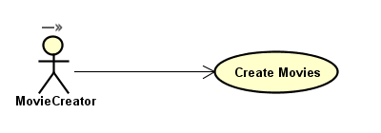

Figure 1 - Movie Creator Use Case

[Activity Diagram For Creating Movie]

The employee that operates the application can also list the current movies from the database in order to ensure that his actions were successful without requiring relying on a different component.

The Movie Manager is the next component in the chain. This one can rent movies that have been created by the previous link, as long as they have not already been rented. In broad terms, it functions quite similarly to the Movie Creator but has a more restricted access to the data it works with.

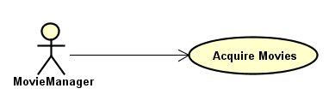

Figure 2 - Movie Manager Use Case

An employee is able to retrieve a list of the currently unrented movies from the database and then simply insert the id of the movie he wants to rent in the application and the system will store it as rented. Once this is complete, the list will be automatically updated and the rented movie removed from the list.

[Activity Diagram for Movie Manager]

The third component is the Movie Scheduler. It is definitely the most complex one since it can do a lot more than the others combined. The scheduler can create and manage rooms for the cinema as well as take the movies that the previous component has rented and schedule them for screening using the available rooms.

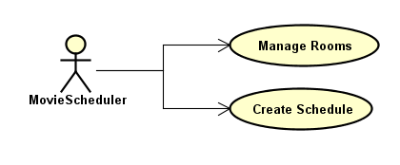

Figure 3 - Movie Scheduler Use Case

The employee working as the scheduler can also send the scheduled movies available for the week to the next and last component of the system, the one that handles customer interaction. This part of the system can also retrieve and manipulate information from the database such as getting the list of available movies to be scheduled or even deleting rooms from the system.

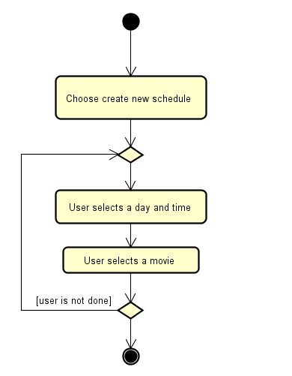

Figure 4 - Create Schedule Diagram

The last component is called the Ticket Booker and is the only component in the system that handles and allows for customer interaction. Using the information from the previous component, the component allows the customer to input data through the cinema’s official website.

The customer can see this week’s scheduled movies and can select one from the list. Once selected he will be able to see all available seats in the room as well as the ones that have been taken. He can then pick the number of a seat and with a single click of a button the system will register his booking for that seat.

All that is left to do for the customer is to give his personal e-mail and telephone number so that the information can be sent to him and then he needs to show up thirty minutes before the screening to receive his ticket.

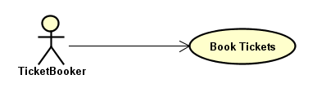

Figure 5 - Ticket Booker Use Case

[Activity diagram for booking ticket]

As seen from these figures, the system is easy to understand and more importantly, easy to use for both customers and employees of the cinema, a trait highly appreciated by both consumers and stakeholders.

# System Design

# System Implementation

The implementation uses the diagrams and specifications mentioned in the Design to create the whole system. The system was created using a 3-tier architecture and two different programming languages. The focus of this chapter will be to explain what facilitates the communication between the tiers.

The Movie Creator and Movie Manager components are similar in the methods they employ. Explaining how the communications is done in the Movie Manager will also cover the Movie Creator.

The communication protocol that is used in the system is TCP (transfer control protocol). Once two sockets are connected, they can be used to transmit data in both directions.

The communication in Movie Manager between tiers is achieved through TCP sockets. Tier 1 only acts as a client, sending out request to the server that is Tier 2 in order to receive data. First, it connects to the server socket, that is listening for clients, through a specific port and opens an Input Stream, which is used as a channel to send the requests, and an Output Stream, which is used as channel to receive the response from the server.

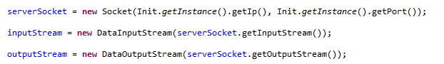

In the case of renting, when the user asks for the request to be sent, the system translates it into Json, sends in through the InputStream to the server that is waiting to handle request from the user.

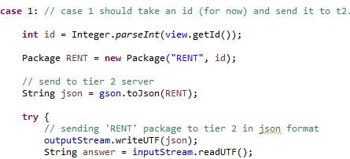

The next of the step is waiting for the answer, decoding it from Json to the Package class and reading the contents. The view will act according to the response it receives and display the movies that are available to rented if it has been successful.

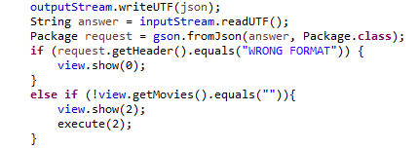

Tier 2 in Movie Creator acts both as a client and a server. As a server, it waits for the input, translates it from Json, does the specific actions to the header of the package sent and send the response to the client.

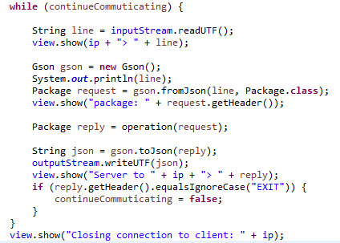

As a client, it acts when it needs to persist data or receive data that was already persisted on Tier 3. In the case of communication between the Tier 2 and Tier 3, the connection is opened on a per request basis. In between Tier 1 and Tier 2, continuous communication is desired to ensure a better user experience, but in between Tier 2 and Tier 3, there is no need for that. It doesn’t keep the database waiting more than is necessary.

Tier 3 is written in C#, meaning that Tier 2 needs to handle the communication in a different way. Json in Newtonsoft serializes nulls by default, but Gson in java doesn’t. The Gson builder was adjusted to ensure that both tiers can understand each other’s message.



In JAVA sockets, the communication is done through a special kind of UTF in which the first two bytes sent are about the size of the message. C# uses the default UTF-8 format in which the system waits for something to signal the end of stream or message. To solve this issue, the response from Tier 3 is handled with a buffered reader that waits for a Newline or a EOF (End of Stream) to know that all the message has been sent. In the case of the following code, it waits for an EOF.

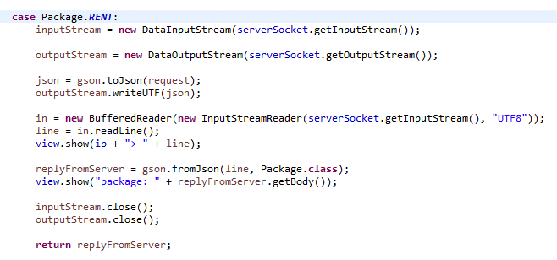

Tier 3 only acts as a server for Tier 2. For convenience, the message sent to the database was kept in the special UTF specific to JAVA. The solution to reading the message was to skip the first two bytes when the string in UTF 8 is decoded, so the message could be converted through Json.

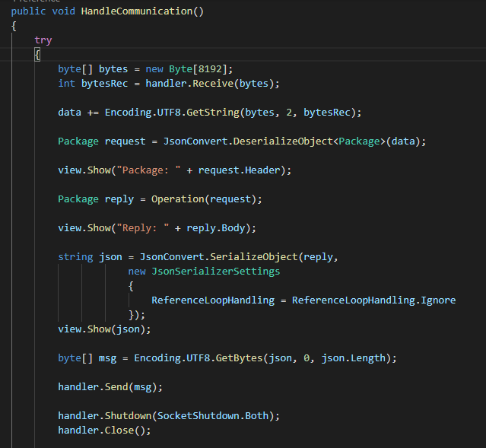

After the message is sent, the stream is closed so the Tier 2 receives the EOF.

In order to introduce the last component, the Ticket Booker, the Tier 2 in Movie Scheduler needed some adaptations. It’s special because it has as clients both the C# web API and the JAVA Client. It could not receive the messages in the usual UTF from JAVA, so it was adapted to read with a BufferedReader. To know when the web API is done sending the message it receives a Newline.

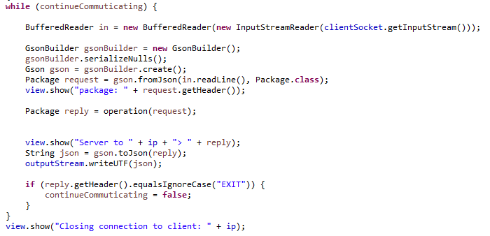

The client in JAVA had to be modified to also send a Newline at the end of each message and flush to make sure that are the bytes have been written because the program can be closed at any time by the user.

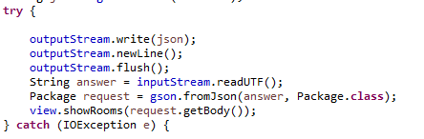

To receive the schedule, the controller uses a class through dependency injection that connects to the Tier 2 in JAVA to ask for the data. In this way, we make sure that the schedule is received only once at the start of the web API and not each time a user has a request.

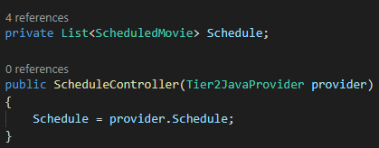

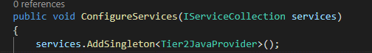

The web API uses TcpClient to connect to Tier 2 in Movie Scheduler and creates a NetworkStream to be used for writing and reading messages.

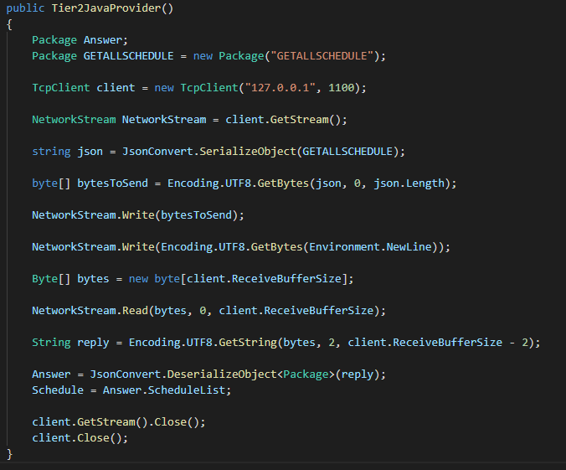

When receiving the reply, it skips the first two bytes again. To make sure that it doesn’t read more than it needs to, it has 2 subtracted from the total size of the message.

On the last part of the Implementation, the analysis of the communication on Tier 1 in the Ticket Booker will come into attention.

The way it receives data is through a GET request to the web API for the scheduled movies. To save the booked tickets, it uses a PUT request in which it introduces the link the desired movie and, the desired seat to book in the body. After the PUT request the web API sends a request for the schedule to be updated with the new seats.

On the GET request, the client sets as a header "application/json" so it knows that it wants to receive the information in Json. If the web API sends a success status code, then the response is read.

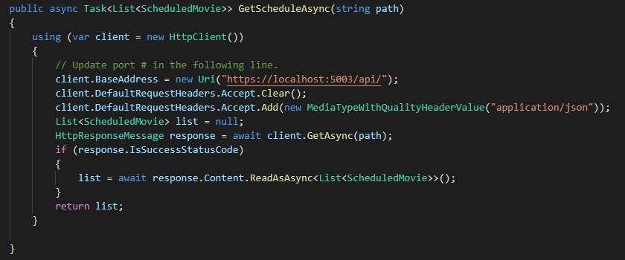

On the PUT request, the client sets the header again to know it sends json. If the request is successful, then it lets the client know by returning true and if it fails, it catches the exception and signals to the client to show an error page.

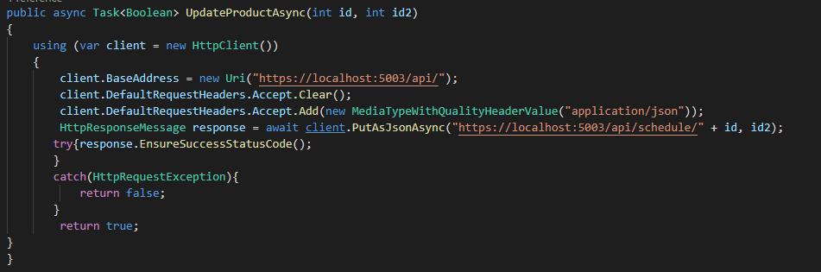

This concludes the explanation on how the communication was done and how it works in the current system. Next comes testing in which the system will be put through different scenarios to ensure that it behaves as expected.

# Testing

As the focus was communication and having a 3-tier architecture, there wasn’t much in the implementation of the model in each tier. The JUnit tests verify if the validation is done properly. Most of the system is tested using Test Cases that check the behaviour of the system. The JUnit tests can be found in Appendix “”.

Test Specifications

Test Cases were used to ensure that the Use Cases and the requirements have been respected. The following table displays all the test specifications:

|  |  |  |  |  |  |  |
| --- | --- | --- | --- | --- | --- | --- |
| Nr | Description | Actor | Precondition | Expected Result | Steps | Result |
| 1 | The user creates a movie | Movie Creator | The system must be connected to the database | A movie is created and added to the list | 1. User presses on the button “CreateMovie”  2. User introduces title and submits  3. User introduces creation year and submits  4. User introduces release date and submits  5. User introduces price and submits  6. User introduces the name of the studio and submits  7. User introduces the director’s name and submits  8. User introduces the description and submits  9. User introduces the main actor’s name and submits | A movie is created and added to a list. |
| 2 | The user wants to create a movie but inputs the year of creation in the wrong format | Movie Creator |  | The system displays an error message “Input a creation year made by digits” | 1. User presses on the button “CreateMovie”  2. User introduces title and submits  3. User introduces creation year and submits | The system displays an error message “Input a creation year made by digits” |
| 3 | The user wants to create a movie but inputs the release date in the wrong format | Movie Creator |  | The system displays an error message “Please enter the date in this exact format: [DD/MM/YYYY]” | 1. User presses on the button “CreateMovie”  2. User introduces title and submits  3. User introduces creation year and submits  4. User introduces release date and submits | The system displays an error message “Please enter the date in this exact format: [DD/MM/YYYY]” |
| 4 | The user wants to create a movie but inputs the price in the wrong format | Movie Creator |  | The system displays an error message “Input a price made by digits” | 1. User presses on the button “CreateMovie”  2. User introduces title and submits  3. User introduces creation year and submits  4. User introduces release date and submits  5. User introduces price and submits | The system displays an error message “Input a price made by digits” |
| 5 | The user wants to create a room | Movie Scheduler | The system must be connected to the database | A room is created and added to a list | 1. User chooses to create a room  2. User enters size of the room  3. User enters description  4. User validates his choice  5. Room is created and added to the list | A room is created and added to a list |
| 6 | The user wants to create a room but inputs the size in the wrong format | Movie  Scheduler | The system must be connected to the database | The system displays an error message “You need to input a number” | 1. User chooses to create a room  2. User enters size of the room | The system displays an error message “You need to input a number” |
| 7 | The user wants to delete a room | Movie Scheduler | The system must be connected to the database | The selected room will be removed from the system | 1. System displays a list of all rooms  2. User selects a room from the list  3. User deletes the room  4. System removes room from the list | The selected room will be removed from the system |
| 8 | The user wants to delete a room but doesn’t input the ID in the field or inputs the wrong format | Movie Scheduler | The system must be connected to the database | The system displays an error message “You need to input a number in the ID field” | 1. System displays a list of all rooms  2. User selects a room from the list | The system displays an error message “You need to input a number in the ID field” |
| 9 | The user wants to create a schedule | Movie Scheduler | Rooms are stored in the system  Managed list of movies is stored in the system  The system must be connected to the database | Schedule created and added to the database | 1. System displays a list of available movies, rooms, days and times  2. User inputs the id of the movie.  3. User inputs the id of the room.  4. User selects the day from a list of available days.  5. User selects the time from a list of available times.  6. User presses a button with the text “Input”.  7. Steps 2 to 7 are repeated until the user decides he/she is done.  12. After he is done, the user can press the button with the text “Send” to send over to the database the schedule. | Schedule created and added to the database |
| 10 | The user wants to see the current schedule | Movie Scheduler | Rooms are stored in the system  Managed list of movies is stored in the system  A schedule in the system  The system must be connected to the database | Schedule data displayed | 1. User presses the button “show” | Schedule data displayed |
| 11 | The user wants to create a schedule but doesn’t input the ID of Room or/and Movie | Movie Scheduler | Rooms are stored in the system  Managed list of movies is stored in the system  The system must be connected to the database | The system displays a message “Wrong ID/Wrong format Inputted (Must be a number present in the list written with digits)” | 1. System displays a list of available movies, rooms, days and times.  4. User selects the day from a list of available days.  5. User selects the time from a list of available times.  6. User presses a button with the text “Input”. | The system displays a message “Wrong ID/Wrong format Inputted (Must be a number present in the list written with digits)” |
| 12 | The user wants to create a schedule but doesn’t a number as the ID of Room or/and Movie | Movie Scheduler | Rooms are stored in the system  Managed list of movies is stored in the system  The system must be connected to the database | The system displays a message “Wrong ID/Wrong format Inputted (Must be a number present in the list written with digits)” | 1. System displays a list of available movies, rooms, days and times  2. User inputs the id of the movie.  3. User inputs the id of the room.  4. User selects the day from a list of available days.  5. User selects the time from a list of available times.  6. User presses a button with the text “Input”. | The system displays a message “Wrong ID/Wrong format Inputted (Must be a number present in the list written with digits)” |
| 13 | The user wants to create a schedule but doesn’t input the ID of a Room or/and Movie from the list | Movie Scheduler | The system must be connected to the database | The system displays a message “Wrong ID/Wrong format Inputted (Must be a number present in the list written with digits)” | 1. System displays a list of available movies, rooms, days and times  2. User inputs the id of the movie.  3. User inputs the id of the room.  4. User selects the day from a list of available days.  5. User selects the time from a list of available times.  6. User presses a button with the text “Input”. | The system displays a message “Wrong ID/Wrong format Inputted (Must be a number present in the list written with digits)” |
| 14 | The user wants to rent a movie that is not rented | Movie Manager | Movies that are not rented in the database | A movie is rented by the Movie Manager | 1. System displays list of movies that are not rented  2. User inserts a movie id  3. System registers the movie as rented  4. The system displays a pop-up message informing the user of the successful operation  5. The system automatically updates the list of movies that are not rented | A movie is rented by the Movie Manager |
| 15 | The user wants to rent a movie, but the list is empty | Movie Manager | Empty list of movies that are not rented | System displays a pop-up message with “No Available Movies” | 1. System displays list of movies that are not rented | System displays a pop-up message with “No Available Movies” |
| 16 | The user wants to rent a movie that doesn’t exist or is rented already | Movie Manager | Movies that are not rented in the database | System displays an error message with “Invalid Input” | 1. System displays list of movies that are not rented  2. User inserts a movie id  3. User presses the button “Rent Movie” | System displays an error message with “Invalid Input” |
| 17 | The user wants to rent a movie and inputs something else instead of a number in the id field | Movie Manager |  | System disables the rent button | 1. System displays list of movies that are not rented  2. User inserts a movie id | System disables the rent button |
| 18 | The user rents a movie and then the list of movies that are not rented is empty | Movie Manager | Movies that are not rented in the database | System displays a pop-up message with „No Available Movies” | 1. System displays list of movies that are not rented  2. User inserts a movie id  3. System registers the movie as rented  4. The system displays a pop-up message informing the user of the successful operation  5. The system automatically updates the list of movies that are not rented | System displays a pop-up message with „No Available Movies” |

# Results and Discussion

# Conclusion

# Project Future

# List of Appendices

# Sources of Information

# **Bibliography**

Danish Film Institute, 2012. *dfi.dk.* [Online]   
Available at: https://www.dfi.dk/files/docs/2018-02/f_and_f_2012_screen_singlepages%20%281%29.pdf  
[Accessed 20 September 2018].

Danish Film Institute, 2017. *dfi.dk.* [Online]   
Available at: https://www.dfi.dk/files/docs/2018-02/Facts%20and%20Figures%202017%20%281%29.pdf  
[Accessed 20 September 2018].

Danish Film Institute, 2018. *dfi.dk/.* [Online]   
Available at: https://www.dfi.dk/files/docs/2018-04/Facts-and-figures-2018_0.pdf  
[Accessed 20 September 2018].

http://www.upedu.org/, 2018. *http://www.upedu.org/.* [Online]   
Available at: http://www.upedu.org/  
[Accessed 20 September 2018].

media.netflix.com, 2012. *media.netflix.com.* [Online]   
Available at: https://media.netflix.com/en/press-releases/netflix-launches-in-sweden-denmark-norway-and-finland-migration-1  
[Accessed 20 September 2018].

Motion Picture Association of America, 2017. *mpaa.org.* [Online]   
Available at: https://www.mpaa.org/wp-content/uploads/2017/03/MPAA-Theatrical-Market-Statistics-2016_Final.pdf  
[Accessed 20 September 2018].

Nielsen, M. B., 2018. *dst.dk.* [Online]   
Available at: https://www.dst.dk/en/Statistik/emner/kultur-og-kirke/film-boeger-og-medier/biografer-og-film  
[Accessed 20 September 2018].

POSitive Cinema, 2018. *http://positivecinema.com/.* [Online]   
Available at: http://positivecinema.com/  
[Accessed 20 September 2018].

Scrum.org, 2018. *Scrum.org.* [Online]   
Available at: https://www.scrum.org/resources/what-is-scrum  
[Accessed 20 September 2018].

Vista Cinema, 2018. *Vista.* [Online]   
Available at: https://www.vista.co/en/vista-products/vista-products/cinema/  
[Accessed 20 September 2018].